42.41: a) 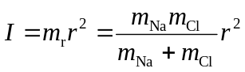
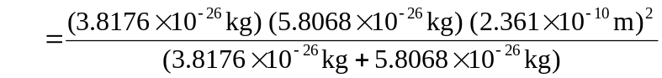
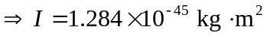
For 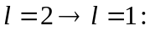 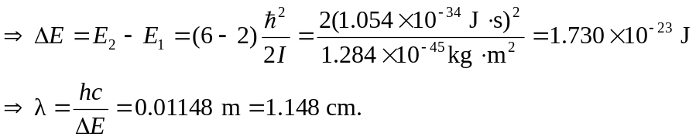
For 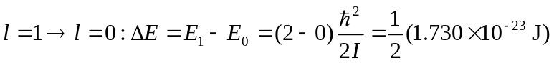
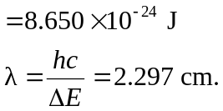
b) Carrying out exactly the same calculation for 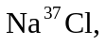 where 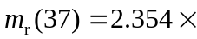
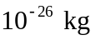and I(37)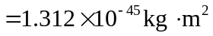 we find for
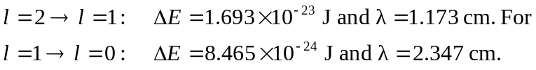
So the differences in wavelength are:
